Site Experience #6.00

Site Experience #6.00 1
Brief 1
Reflective - What did I learn? 1
End to End test 2
The figure of eight test 2
The figure of eight test we conduct the following two tests: 2
For example, if the R1 and RN = 0.40 ohms. Then we expect
R1 and R2 = 0.668 ohms. 2
Comparatively, R1 and R2 should be 1.67 times higher than the R1 and RN wire. This is because 2.5mm2 divide by 1.5mm2 = 1.67. 2
Loop impedance test 2

Brief

On this day I was based the entire day in Oakham the whole day as I worked on an installation project.

Reflective - What did I learn?

- Ring circuits were introduced after World War Two because there was a copper shortage.
- Sockets are always on a ring final circuit.
- In the rose ceiling circuit we placed all the red wires into the Loop section.
- The cooker is on a radial circuit.
- Lights are on a radial circuit.

End to End test

Is a continuity test which ensures that the wire is connected the whole way around.

The figure of eight test

The figure of eight test we conduct the following two tests:
R1 and R2
R1 and RN.

For example, if the R1 and RN = 0.40 ohms. Then we expect
R1 and R2 = 0.668 ohms.

Comparatively, R1 and R2 should be 1.67 times higher than the R1 and RN wire. This is because 2.5mm² divided by 1.5mm² = 1.67.

Loop impedance test

He performed a test in which no modifications were made to the fuse board. On the tester there are two sections: Live testing and Dead testing.

He plugged the chords into Live, Earth and Neutral. Then on the opposite end he plugged a three pin plug into the sockets.

He mentioned that this is a Live test and checks the Earth Fault Loop impedance.

On the ring circuit there were for plugs the readings were as follows:

First socket: 0.30
Second socket: 0.32
third socket:0.30
Fourth socket: 0.30

Photographic content

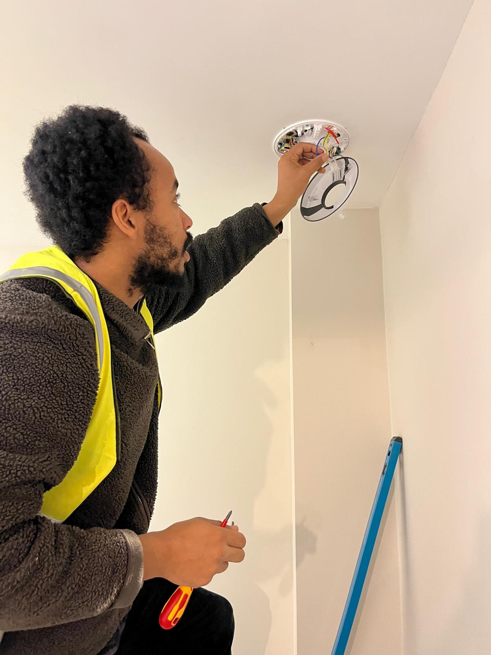

Connecting a humidistat time fan

